What is Climate Change
Climate change refers to significant, long-term changes in the global climate.
The global climate is the connected system of sun, earth and oceans, wind, rain and snow, forests, deserts and savannas, and everything people do, too. The climate of a place, say New York, can be described as its rainfall, changing temperatures during the year and so on.
But the global climate is more than the “average” of the climates of specific places.
A description of the global climate includes how, for example, the rising temperature of the Pacific feeds typhoons which blow harder, drop more rain and cause more damage, but also shifts global ocean currents that melt Antarctica ice which slowly makes sea level rise until New York will be under water.
It is this systemic connectedness that makes global climate change so important and so complicated.
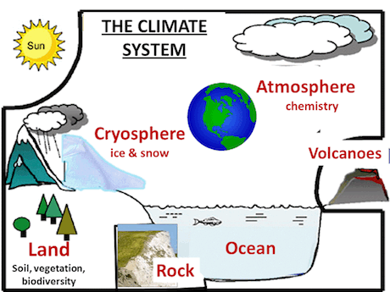

(Source: US Environmental Protection Agency)

What is Global Warming?
Global warming is the slow increase in the average temperature of the earth’s atmosphere because an increased amount of the energy (heat) striking the earth from the sun is being trapped in the atmosphere and not radiated out into space.
The earth’s atmosphere has always acted like a greenhouse to capture the sun’s heat, ensuring that the earth has enjoyed temperatures that permitted the emergence of life forms as we know them, including humans.
Without our atmospheric greenhouse the earth would be very cold. Global warming, however, is the equivalent of a greenhouse with high efficiency reflective glass installed the wrong way around.
So much heat is being kept inside greenhouse earth that the temperature of the earth is going up faster than at any previous time in history. NASA provides an excellent course module on the science of global warming.
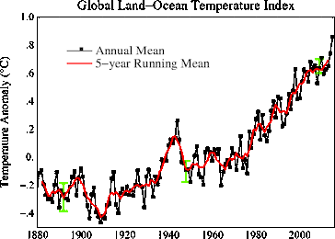

(Source: NASA)
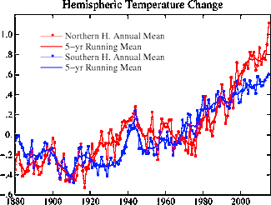

(Source: NASA)
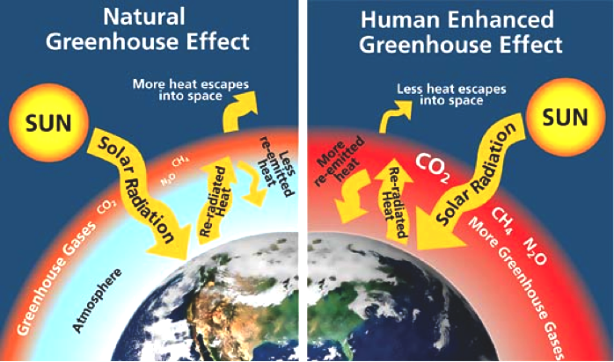

(Source: Center for Climate and Energy Solutions)

How does Global Warming drive Climate Change?
Heat is energy and when you add energy to any system changes occur.
Because all systems in the global climate system are connected, adding heat energy causes the global climate as a whole to change.
Much of the world is covered with ocean which heats up. When the ocean heats up, more water evaporates into clouds.
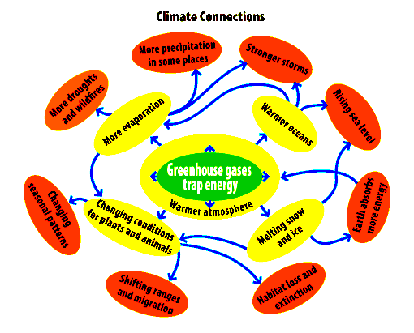

(Source: US Environmental Protection Agency)
Where storms like hurricanes and typhoons are forming, the result is more energy-intensive storms. A warmer atmosphere makes glaciers and mountain snow packs, the Polar ice cap, and the great ice shield jutting off of Antarctica melt raising sea levels.
Changes in temperature change the great patterns of wind that bring the monsoons in Asia and rain and snow around the world, making drought and unpredictable weather more common.
This is why scientists have stopped focusing just on global warming and now focus on the larger topic of climate change.

